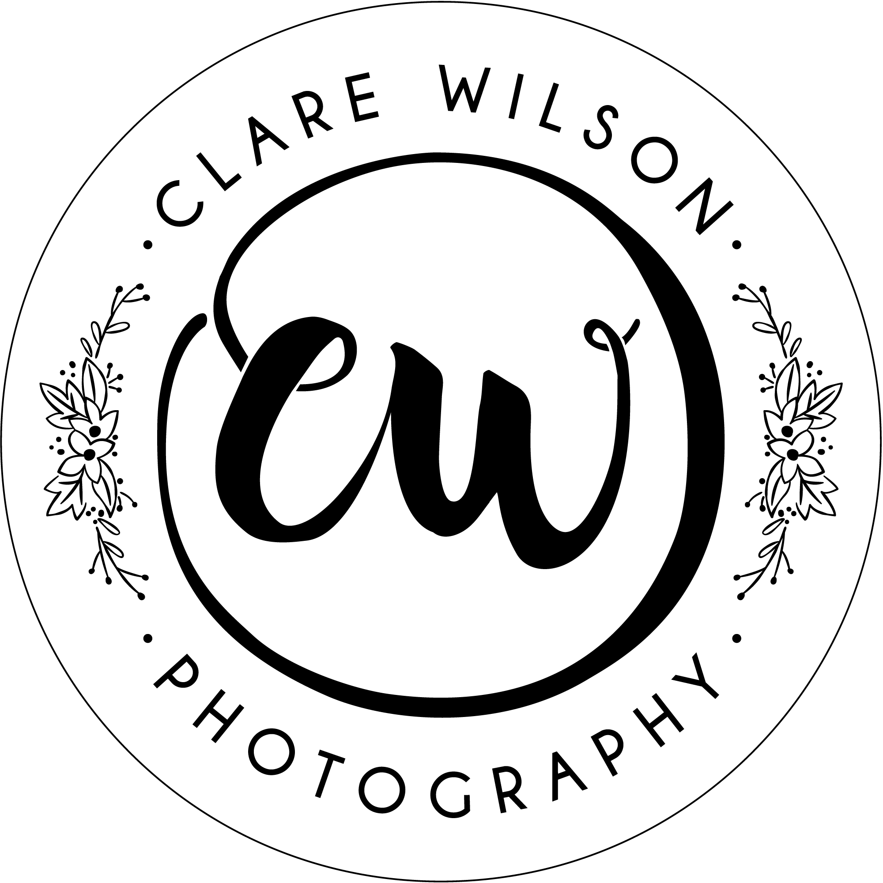
Clare Wilson Photography - Model Release Form
An agreement between the photographer and model to allow the use of photographs from the photographic session detailed below. This does NOT cover any other photographs of the same model taken at any other time.

Photographer | Clare Wilson
Company Name | Clare Wilson Photography
Address | 9, St Teilos Way, Caerphilly, CF83 1FA
Session | Christmas Mini Session
Date | Monday 16th November 2020
Location | Bijou Nursery, 48A Eastgate, Cowbridge, CF71 7AB

Name(s) of Child(ren)
Name of Parent/Guardian
Email Address

THE AGREEMENT

I named above hereby give permission to Clare Wilson to take photographs of my child in connection with the above session. I authorise Clare Wilson full copyright use and publishing rights of these photographs. Photographs will be uploaded to an on-line gallery with password protect for the Parent/Guardian viewing only.

(Please also answer the following:)
YES / NO | I am happy for Clare Wilson to use such photographs of my child for such purposes as publicity, advertising and web content
YES / NO | I am happy for Clare Wilson to post a photo of my child/children on their Social Media (Instagram/Facebook) – images are never posted with children’s names.
YES / NO | I am happy to be added to Clare Wilson’s email mailing list to be informed about future photoshoots and special offers available.
Please Note - You can ask Clare Wilson to stop using your child/ren’s images at any time, in which case they will not be used in future publications but may continue to appear in publications already in circulation.
I have read and understood the above.
To indicate your acceptance of this contract, and the terms and conditions (viewable on www. clarewilsonphotography.co.uk/home/sessions/christmas-at-bijou/),
type your name in the box below:

NAME: | DATE:

